Diagnostics Form
Please provide as much information as you can so we can make an accurate and speedy diagnosis of your issues.

Email address

Vehicle Registration

Are you the main driver of this vehicle?
- Yes
- No

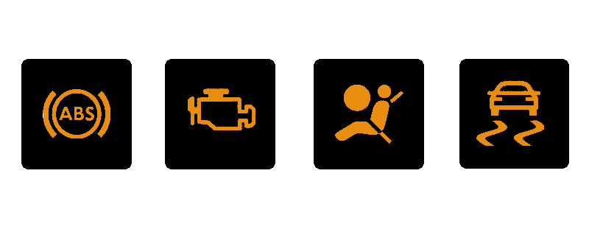
Which lights appear on the dash of your car?
- Engine Management Light (2)
1 2 3 4
- ABS Light (1)
- Traction Light (4)
- Glow Plug Light (6)
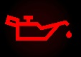
- Oil Light (5)
- Airbag Light (3)
- Brake Warning Light (7)
5 6 7

Please tick ALL the symptoms that apply to your issue:
- Turns over but won’t start
- Won’t turn over
- Engine stalls
- Engine misfires
- Rough idle
- High idle
- Low idle
- Low power/lack of performance
- Losing oil
- Losing water
- Knocking/unusual noises
- Fuel economy noticeably worse
- Other
How often does the issue happen?
- Always
- Every few minutes
- Every few days
- Every few weeks
- Every few months
- Randomly
Driving conditions when issues occur:
- Starting
- At idle
- Light acceleration
- Heavy acceleration
- In traffic
- Fast roads
- Over bumps
- Slowing down
- Turning left
- Turning right
- Up hill
- Down hill
- Anytime
- Changing gears
- Other

Does the issue seem worse when the engine is?
- Cold
- Warm
- Hot
- All the time
- Other

Weather condition when issue happens/first happened:
- Snowy
- Icy
- Cold
- Rainy
- Warm
- Hot
- Dry
- Any Weather

When did the issue first happen?
- Today
- Few days ago
- Few weeks ago
- Since I bought the car
- Since a previous repair was carried out
- Other

When the vehicle was last worked on (if not by PR Motors)?

Please provide us with any additional information about the vehicles issues that may be useful:

